**Practical No. 6**

**Aim: To implement full adder combinational circuit.**

**Apparatus:** Logic Gate ICs, Connecting wires, Bread Board, Power supply, LED, DMM.

**Theory:**

Full adder is developed to overcome the drawback of Half Adder circuit. It can add two one­bit numbers A and B, and carry c. The full adder is a three input and two output combinational circuit.

**BLOCK DIAGRAM:**

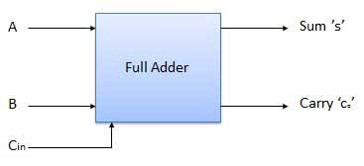

**TRUTH TABLE:**

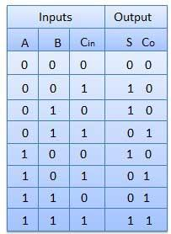

**Combinational Logic:**

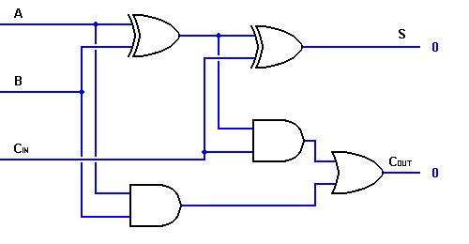

**Procedure:**

1. Do the connection as per Combinational logic diagram for various input data.
2. Apply proper input condition and observe the output information of using DMM.
3. Compare theoretical data with observation and write conclusion.

**Observation Table:**

**Tinker Cad Simulation:**

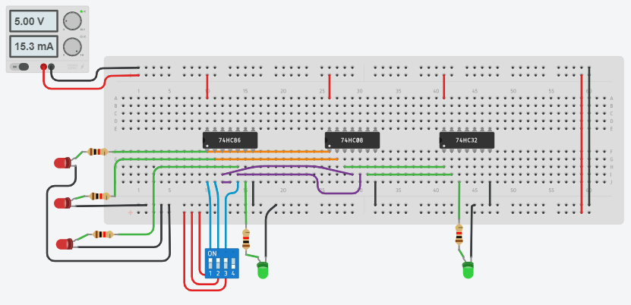

**Observation Table:**

|  |  |  |  |  |
| --- | --- | --- | --- | --- |
| **Inputs** | | | **Outputs** | |
| **A** | **B** | **C** | **Sum (s)** | **Carry (c)** |
| 0 | 0 | 0 | 0 | 0 |
| 0 | 0 | 1 | 1 | 0 |
| 0 | 1 | 0 | 1 | 0 |
| 0 | 1 | 1 | 0 | 1 |
| 1 | 0 | 0 | 1 | 0 |
| 1 | 0 | 1 | 0 | 1 |
| 1 | 1 | 0 | 0 | 1 |
| 1 | 1 | 1 | 1 | 1 |

**CONCLUSION:**

A full adder circuit is central to most digital circuits that perform addition or subtraction. It is so called because it adds together two binary digits, plus a carry-in digit to produce a sum and carry-out digit.